**Lab 4**

**Isa Dzhumabaev**

**Save the output of the program in your lab report**

$ ./a.out

validated

quadsort: sorted 100000 i64s in 0.013857 seconds. (random order)

qsort: sorted 100000 i64s in 0.012997 seconds. (random order)

quadsort: sorted 100000 i32s in 0.013584 seconds. (random order)

qsort: sorted 100000 i32s in 0.012799 seconds. (random order)

quadsort: sorted 100000 i32s in 0.000263 seconds. (ascending)

qsort: sorted 100000 i32s in 0.000528 seconds. (ascending)

quadsort: sorted 100000 i32s in 0.002616 seconds. (ascending saw)

qsort: sorted 100000 i32s in 0.007200 seconds. (ascending saw)

quadsort: sorted 100000 i32s in 0.010146 seconds. (generic order)

qsort: sorted 100000 i32s in 0.004536 seconds. (generic order)

quadsort: sorted 100000 i32s in 0.000364 seconds. (descending order)

qsort: sorted 100000 i32s in 0.002670 seconds. (descending order)

quadsort: sorted 100000 i32s in 0.002515 seconds. (descending saw)

qsort: sorted 100000 i32s in 0.005236 seconds. (descending saw)

quadsort: sorted 100000 i32s in 0.003542 seconds. (random tail)

qsort: sorted 100000 i32s in 0.006575 seconds. (random tail)

quadsort: sorted 100000 i32s in 0.007406 seconds. (random half)

qsort: sorted 100000 i32s in 0.011522 seconds. (random half)

quadsort: sorted 100000 i32s in 0.005104 seconds. (wave order)

qsort: sorted 100000 i32s in 0.006501 seconds. (wave order)

quadsort: sorted 100000 i32s in 0.009738 seconds. (stable)

qsort: sorted 100000 i32s in 0.005025 seconds. (unstable)

quadsort: sorted 8 i32s in 0.000052 seconds. (random 1-8)

qsort: sorted 8 i32s in 0.000035 seconds. (random 1-8)

quadsort: sorted 15 i32s in 0.000145 seconds. (random 9-15)

qsort: sorted 15 i32s in 0.000175 seconds. (random 9-15)

quadsort: sorted 15 i64s in 0.000096 seconds. (random 1-15)

qsort: sorted 15 i64s in 0.000106 seconds. (random 1-15)

quadsort: sorted 63 i32s in 0.000898 seconds. (random 16-63)

qsort: sorted 63 i32s in 0.001303 seconds. (random 16-63)

quadsort: sorted 127 i32s in 0.002620 seconds. (random 64-127)

qsort: sorted 127 i32s in 0.004788 seconds. (random 64-127)

quadsort: sorted 255 i32s in 0.005723 seconds. (random 128-255)

qsort: sorted 255 i32s in 0.011384 seconds. (random 128-255)

quadsort: sorted 511 i32s in 0.014032 seconds. (random 256-511)

qsort: sorted 511 i32s in 0.025942 seconds. (random 256-511)

quadsort: sorted 1023 i32s in 0.040460 seconds. (random 512-1023)

qsort: sorted 1023 i32s in 0.058153 seconds. (random 512-1023)

quadsort: sorted 1023 i32s in 0.024502 seconds. (random 1-1023)

qsort: sorted 1023 i32s in 0.036731 seconds. (random 1-1023)

quadsort: sorted 2047 i32s in 0.110264 seconds. (random 1024-2047)

qsort: sorted 2047 i32s in 0.127463 seconds. (random 1024-2047)

quadsort: sorted 4095 i32s in 0.479185 seconds. (random 2048-4095)

qsort: sorted 4095 i32s in 0.512234 seconds. (random 2048-4095)

**What is the main advantage of this sort? Explain shortly in 4-5 sentences**

As I understood the main advantage is quad swap that reduces a lot of redundant swaps. Another thing is detecting sorted parts in the array in order to skip sorting and merging, which would be useless. And also it does not check bounds of the array, instead it compares last elements of two arrays. But as it was said by author the main advantage is quad swap.

**How is the program measuring the running time?**

Time is measured using utime.h header. Just saving the starting time and end time then subtraction.

**What about the space issues?**

Answer is in readme file of author ☺

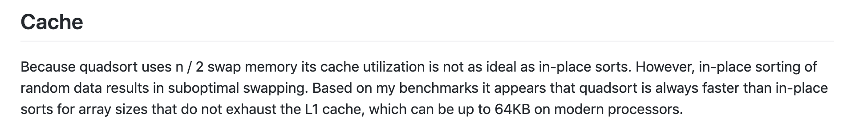

**Can you increase to more than 4 (quad)?**

I think that theoreticaly it is possible, but the quiestion is «do we need it?». I think that in most cases best solutions are created from totaly new ideas rather from evloving of old solution.